Design: Block Trade Display

Overview

Current processing
New functionality.

New requirement:
The block trade function is used to display trades on the data wall on the trading floor. The trades that are displayed belong to specific product classes and have a trade volume criterion for each of these product classes. Traders on the exchange floor refer to this display.

Implementation

consumer.idl
The changes to the IDL are in-place.
IDL name – consumer.idl
Module name - consumers
Interface name - TickerConsumer – An operation called
void acceptLargeTradeTickerDetailForClass(in util::RoutingParameterStruct routingParameters, in marketData::InternalTickerDetailStructSequence tickerDetails );

TradeReportImpl
This class will publish block trade display events on the TickerConsumer channel.
- Write a new method void publishLargeTradeTicker(InternalTickerDetailStruct internalTickerDetailStructs )
Which will publish block trade event on ticker consumer channel.
If (lastSale volume is greater or equal to block trade size for class)
{
if(last sale prefix is non of these CANC,CNCL,CNCO,CNCO)
{
for(number of contra parties involved)
{
acceptLargeTradeTickerDetailForClass (array of InternalTickerDetailStructs );
}
}
}
- public void create(String name, TradingProduct product, char tradeType, char settlementTradeType, boolean heldOrderTrade, int quantity, Price price, List parties, TradeReport parent, IdService myIdService) throws SystemException
calls publishLargeTradeTicker(InternalTickerDetailStruct[] internalTickerDetailStructs )

- Add a new instance variable of type InternalTickerDetailStruct which will be populated in
publishTicker(InternalTickerStruct ticker). The values from this struct will be used in publishLargeTradeTicker(..) method. Here it is assumed that publishTicker will be called first to populate the values in struct.

- TradingClassImpl
Enhancements to existing class are required as mentioned below.
  - Add a method called as getLargeTradeTickerSize() to get BlockTradeSize for particular class.
  - Add a method called getTradingPropertyLargeTradeTickerSize() to setLargeTradeTickerSize(). This method gets the value for largeTradeTickerSize trading property.

4. TickersHolder
- Add a getter setter method in this class for InternalTickerDetailStruct[]

5. TickerPublisherBOSessionCollected
- Add acceptLargeTradeTickerDetailForClass method implementation to publish block trade events.

6. TickerDetailObjectCollector
- Create a new object collector for InternalTickerDetailStructs.

7. publishLargeTradeTickerSize Trading Property
- Add a new trading property called as publishLargeTradeTickerSize
- Change TradingPropertyTypeImpl, TradingPropertyFactoryImpl, TradingParameters and TradingClassImpl to accommodate the changes.

8. QuoteTriggerTradeReportImpl
- Change processPendingTrade(..) method to call publishLargeTradeTicker(..) method on TradeReportImpl.

Sequence Diagram
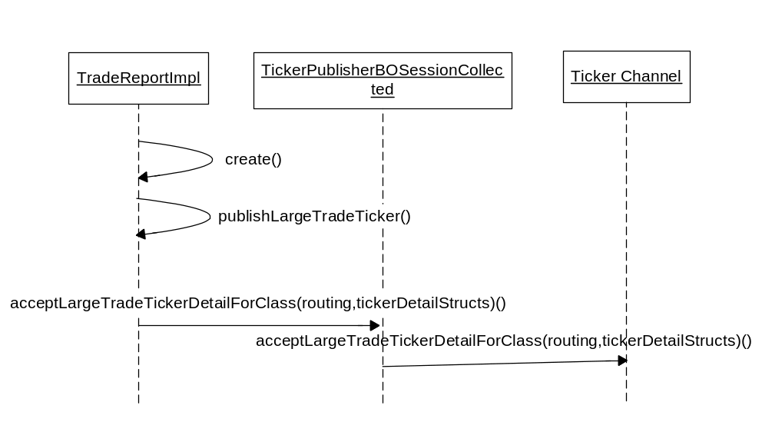
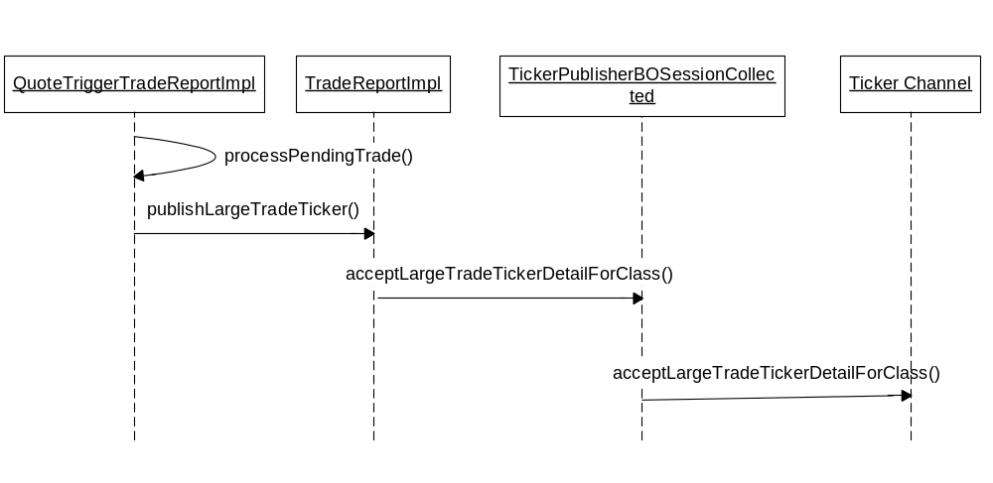

Scripts(2)
None

Database(.5)
None

SetContext(.125)
None

XML/DTD(.5)
None

Homes/Services(2)
None

ImplPlan(.5)
None

PerformanceTestingProcedure(1)
No overhead to system.

TestingProcedure(1)
None

OperatorProcedure(.5)
None

Fallback/Failover
None

GUI Design
None

